FAQs
Download printable version

What will be the life of Granite Hills Wind Farm and how much energy will it generate?
The wind farm will be in operation for about 25-30 years. On average it will generate enough clean energy to power about 50,000 Australian homes.

Will 500 acres of trees be cleared?
No. This number is greatly exaggerated. By using existing roads and cleared areas, the project team have made it a priority to avoid clearing where possible. Current estimates suggest project clearing will be far less than 100 acres.

How many jobs will be offered – short term and long term?
Wind farms create significant job opportunities during construction and for the life of the project. Using published numbers on comparable NSW wind farms as a basis, Granite Hills Wind Farm can expect to create approximately 142 jobs during construction and 13 during operations. As many of these jobs as possible will be sourced from the local community.

I’m a local contractor, how can I become involved during construction?
The project team would love to hear from you. Please send an email to granitehills@akuoenergy.com to let us know who you are, what you do and how you would like to be involved. We will track all inquiries received and reach out when the time is right.
Granite Hills Wind Farm will work with the selected primary contractor to ensure local employment is a priority. Renewable energy projects generally use local resources to minimise cost and reduce time. Appointed primary contractors will be required to prioritise local workers if they are available and suitably qualified for the job.

Are possible impacts on people related to Granite Hills Wind Farm being considered?
Definitely. Granite Hills Wind Farm is required to undertake intensive studies using independent external specialists on everything from noise and visual impacts to water and the environment. There are strict specifications which the project will have to adhere to in order to be given approval to operate.

Will the wind turbines noise affect me?
Granite Hills Wind Farm is being designed according to noise standards from the NSW Department of Environment, which are some of the strictest in the world. They require the sound heard by neighbours to be less than the equivalent sound of rainfall – about the sound of a whisper. The maximum allowable noise level for project neighbours is 35db and we intend to keep all turbines at least 1km away from the nearest neighbour.
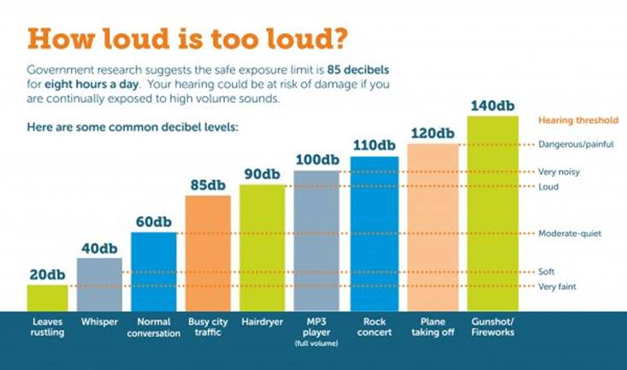
The NSW Department of Planning and Infrastructure has developed a strict criteria to ensure the amenity of an area is not comprised, this criteria have been set to restrict noise generated by wind turbines to 5dB(A) below the lowest acceptable noise criteria for a suburban or rural amenity area (which is 40dB(A) at night) unless the area experiences background noise levels higher than the average 30dB(A) in which case the noise criteria can be up to 5dB(A) above the L90 background noise level. These criteria apply to all periods of the day regardless of whether the acceptable amenity is higher during the day or night.
In 2012, the NSW Government provided a response to the Senate Community Affairs Reference Committee Report on ‘The Social and Economic Impact of Rural Wind Farms’. Within this report, the Australian Government recognised that while the Senate Committee report has captured a range of issues for many individuals and the wider Australian community, there is no strong evidence either way as to the impact of wind farms on the health of Australians. The full response can be found here.

Could the wind farm affect livestock?
All around the world wind farms and animals co-exist in harmony, including in Australia.
In a study by the Centre for Renewable Energy on the Environmental Impacts of Wind Farms – the report stated, there is no indication that wind farms have a negative impact on farming or livestock. In many areas where wind farms are developed, the land is used as pasture for sheep, cattle, goats and other livestock, which continue to graze unhindered after the wind farm has been built. In some wind farms, it has been observed that wind turbines attract sheep and goats in hot weather because they enjoy the shade provided by the towers.
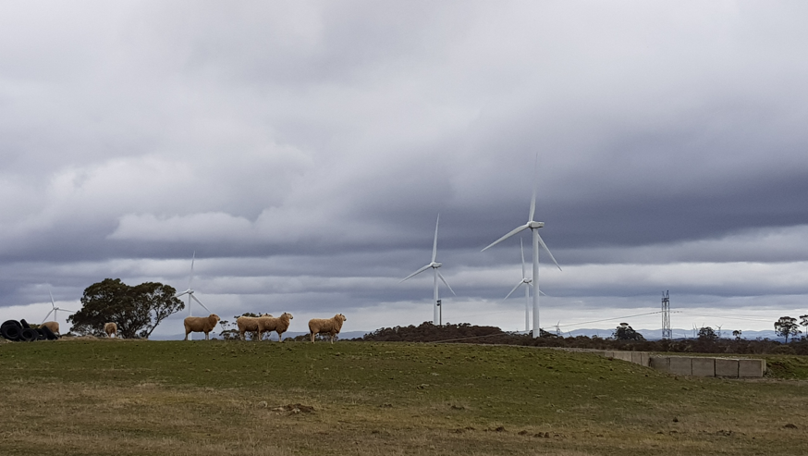

Do wind farms affect property values?
There have been numerous studies into this which have found little to no impact on property value. You can check out a report by Urbis, a well-known and respected company in the property industry. The report can be found on here.
In 2009, the NSW Valuer General commissioned a study, the study investigated eight wind farms across varying land uses (rural, rural residential, residential) using conventional property valuation analysis. Two wind farms were selected in NSW and six in Victoria. The main finding was that the wind farms do not appear to have negatively affected property values in most cases. Forty of the 45 sales investigated did not show any reductions in value. The report went on to say, “No reductions in sale price were evident for rural properties or residential properties located in nearby townships with views of the wind farm”
CleanTechnica summarised statistically reliable and some other studies in various countries. By far the majority of the reliable studies showed no negative impact on the values of properties near wind farms.

Will the wind farm lower my cost of electricity?
Renewable energy is currently the lowest cost new form of energy and vastly cheaper than conventional sources. Having more wind energy in the market will reduce the state-wide cost of generation and should positively impact consumers’ pockets.
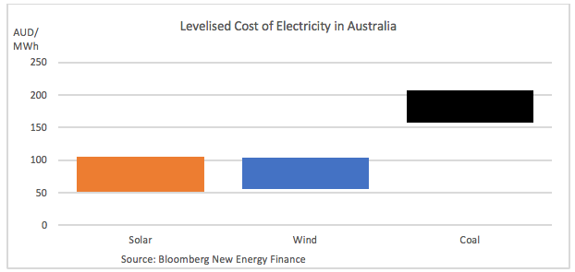

Is there any intention to assist the community?
Most definitely. Granite Hills Wind Farm intends to spread the benefits of the wind farm with the nearby neighbours to the project as well as the wider community. The nature of these programs will be determined over the coming months based upon engagement with the community.

Will the wind farm affect bush firefighting?
Interestingly, access tracks constructed for wind farms are seen as beneficial to fighting bush fires, particularly in remote areas like Granite Hills. While the height of turbines does pose a risk to low flying aircraft, aerial firefighting is routinely done in close proximity to wind farms in Australia and around the world.
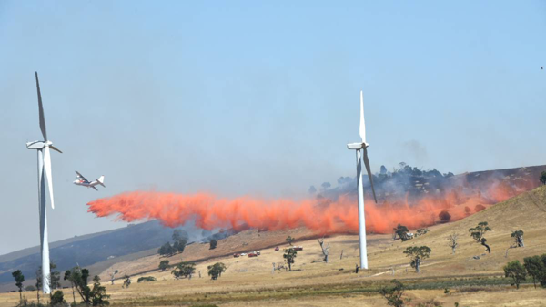
Aerial operations in close proximity to wind turbines are being safely undertaken. Granite Hills Wind Farm will consult Civil Aviation Safety Authority (CASA) and Air Services Australia throughout the development of the project when relevant.
The image of aerial firefighting above is from an expert witness report on the Golden Plains Wind Farm. Pilots of both aerial agricultural and aerial firefighting aircraft now have greater knowledge about wind turbines and are more familiar with operating safety within their vicinity.

When will the turbine layout be available?
The turbine layout will be publicly available when the Environmental Impact Statement is finalised – which we expect will be in Q3 2019.

Where can I find out more information and how do I get in contact?
Visit our website for latest information about the project and to review the Community Plan which outlines how we will interact with the community. If you have any questions or would like to know more, please send an email to granitehills@akuoenergy.com or phone 1800 961 761.

